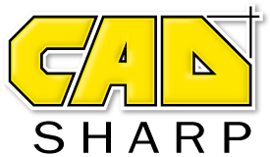
Technical Support Specifications

Please return to keith@cadsharp.com.

Customer Contact Information

Name
Company
Company Address
Email
Phone number

Describe the problem your team is currently facing and your current approach to solving this problem, if there is one.

Example: Our company is writing an addin that will automate the drawing creation of all non-Toolbox components in the active assembly. We are struggling, in particular, with understanding how to automate drawing creation.

What kind of program is your team developing?

[ ] Macro
[ ] Add-in
[ ] Stand-alone
[ ] I want CADSharp to recommend the appropriate type of program.

What language(s) are you using to develop your program?

[ ] VBA
[ ] VB.NET
[ ] C#
[ ] I want CADSharp to recommend a language to my team

Tell us about your team’s programming and SolidWorks API background.

Example: We have one full-time .NET developer and an engineer who provides insight on our engineering process but only knows a little VBA.

What version of SolidWorks / SolidWorks PDM do you use? (Everything you learn will be compatible with future versions of SolidWorks.)
Example: SolidWorks 2017.

If you have any sample files, pictures, or videos that will help us understand your problem, please attach them to your email and explain their purpose here.
- Feel free to paste pictures in this document, if you prefer.
- If you want to take video (without sound), try out Screencast-O-Matic

Example: “Workflow.mp4” is a video showing how we manually automate drawings for one of our more common models.

